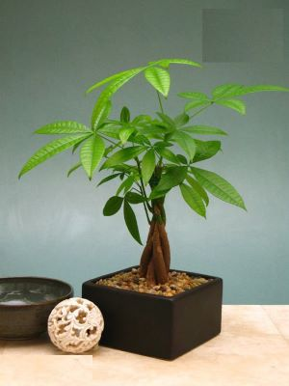

Scientific name: Pachia aquatica (money tree) kim ngân

LIGHT:

Money trees prefer bright, indirect light but can also tolerate low-light conditions. If you are growing your Money tree indoors, place it near a window where it will receive plenty of natural light.

.

WATERING:

Like most tropical plants, the Money tree also enjoys slightly moist soil. You can keep your Money tree happy by watering the plant when the top inch of soil feels dry to the touch. Depending on the size of your plant and the pot it's in, this may be once a week or once every two weeks.Be sure to not overwater your plant as this can cause root rot.

SOIL:

The Money tree grows best in rich, loamy soil that is well-draining. If your pot does not have drainage holes, make sure to add a layer of rocks or gravel to the bottom before adding the soil. This will help ensure that excess water can drain out of reach of the soil and avoid root rot

FERTILIZING:

We recommend fertilizing your Money tree every two to three weeks during the growing season (Spring and Summer). You can use a standard houseplant fertilizer or a slow-release fertilizer. During the fall and winter, you shouldn't fertilize your Money tree at all, as it won't need the extra energy to grow. During the fall and winter, the Money Tree will slow down its growth until the spring

### Temperature and Humidity:

We've already learned that the Money Tree naturally grows in swamps in South America. If you look at its natural habitat, you'll see that it likes humidity. Like its natural rainforest habitat, the Money tree requires humidity; about 50-60%. You can provide this by using a humidifier or placing the plant's pot on a tray filled with pebbles and water.